CYPRUS STARTUP VISA SCHEME

December 2024
Deputy Ministry of Research, Innovation & Digital Policy

- Introduction

The "Cyprus Startup Visa" is part of the Policy Statement on Strengthening the Entrepreneurial Ecosystem. The National Policy Statement for the Enhancement of the Entrepreneurial Ecosystem in Cyprus is a joint action involving all actors of the entrepreneurial ecosystem aiming to exploit business potential, eliminate existing barriers and establish a new, growth-oriented, entrepreneurial culture in Cyprus.
The "Cyprus Startup Visa" Scheme allows talented entrepreneurs from third countries [outside the European Union (EU) and outside the European Economic Area (EEA)], individuals or a team, to enter, reside and work in Cyprus in order to establish / operate / develop a Startup with a high growth potential. The Scheme’s goal is the creation of new jobs, the promotion of innovation and research, the development of the business ecosystem and consequently the economic development of the country.

The Scheme supports the establishment of new innovative Startup or the move of established innovative Startup to Cyprus. Applications for established startups may be for the transfer of an already existing startup to Cyprus or the creation of a branch of the existing startup in Cyprus. In all cases the startup to be established or moved to Cyprus must be an Innovative Startup.

For the purposes of this Scheme, Innovative Startups are defined as unlisted small enterprises up to five years following their registration, which have not yet distributed profits and have not been formed through a merger. The enterprise should have and/or should be developing new products/services/processes that create new or disrupt existing markets. Such products/services/processes are based on new technologies or are adapting existing technologies and/or are employing new business models.

The introduction of the "Cyprus Startup Visa" is part of the Policy Statement on Strengthening the Entrepreneurial Ecosystem.

The Scheme is valid until December 2026 and up to 150 visas can be issued.
This Practical Guide includes all necessary information for applicants.

- Beneficiaries

Individual Startup visa scheme – Eligible is a Non-EU country national who will act as the sole founder of an innovative Startup.

Team Startup visa scheme – Eligible is a Team of maximum 5 individuals consisting of Non-EU country nationals. The Team should consist solely of the founders of an innovative Startup or of at least one (1) founder and other senior executives.

In both the Individual and the Team Startup visa scheme at least 25% of the company's shares should be owned by one or more member(s) of the applicant or team of applicants.

- Benefits in Case of Approval

- Right to economic activity and residence in the Republic of Cyprus for three years, with the possibility of renewal. In the case of renewal, a new application may be submitted three months before the end of the third year, in order to assess the success of the company. If the company is assessed as successful, applicants have the prospect of long-term residence in the Republic.
- For the Founder/s: Right to self-employment or paid employment in their registered company within the Republic.
- For the senior executives (Team Scheme): right to paid employment in a company that the Founders of the Company will register in the Republic.
• For the Founders and Senior Executives family members:
(a) immediate right to residency in the Republic, and
(b) right to family reunification: the right concerns the Founders’ and Senior Executives’ spouse(s) access to the labour market in the same terms and conditions as the sponsor.
- Eligible to obtain a Certificate of Innovative Company.

- Process for Obtaining Initial Approval (DMRID)
All applications should be submitted at: cyprustartupvisa@dmrid.gov.cy.

4.a. CATEGORY A: Startups at Pre-Revenue Stage or Post-Revenue under €1M
A Pre-Revenue Stage Startup is a startup that has not yet generated any revenues from the sale of products/services/processes.
The Applicant/s must submit an application (Annex I) which includes a Business plan demonstrating (1) how the proposed Startup fits the definition according to the EU Regulation no. 651/2014 of 17th June 2014, and (2) the ability of the Startup to develop new or clearly improved products, services or processes with high technological or industrial risk, which are characterized as innovative in their field / market. Startups that introduce disruptive business models creating new revenue streams or creating platform products scaling internationally are also eligible. Guidelines for the preparation of the business plan can be found in Annex ΙI.
All required documents should be submitted in English.
The application may be submitted either while the applicant/s is/are abroad or while they reside legally in the Republic.
The Business Plan is evaluated by two independent evaluators based on specific criteria (Annex IΙΙ). In case the Business Plan secures a score of ≥3 per criterion and ≥ 15/20 in total from both evaluators, then the company qualifies as ‘Innovative’. In case the Business Plan secures a score of ≥3 per criterion and ≥ 15/20 in total by only one evaluator, then the Business Plan is evaluated by a third evaluator. If a score of ≥3 per criterion and ≥ 15/20 in total is secured by the third evaluator, then the company qualifies as ‘Innovative’. In case the Business Plan secures a score of <3 in one criterion and/or <15/20 in total from both evaluators, then the evaluation procedure is complete and the company does not qualify as ‘Innovative’.
4.b. CATEGORY B: Startups at Post-Certain-Revenue-Threshold
The company submits an application (Annex I) demonstrating how the proposed Startup fits the definition according to the EU Regulation no. 651/2014 of 17th June 2014, and a Certificate from an External Auditor (Annex ΙV), certifying that its revenue from the sales of products/services/processes is at least €1mil. according to the most recent audited Financial Accounts AND that its research and development costs represent at least 10% of its total operating costs in at least one (1) of the three (3) previous tax years.
Additionally, the company submits its most recent audited Financial Accounts and the Financial Accounts for the specific year that its R&D costs represent at least 10% of its operation costs. The categories of expenditure on research and development in the financial statements must be clearly defined.

- Approval or Rejection of an Application
The Deputy Ministry of Research, Innovation and Digital Policy approves or rejects the application within five weeks of receiving a completed application.
During the application examination stage, DMRID will request additional documents demonstrating the association of the individual/individuals with the startup (Founder / Co-Founder owing > 25%) or Senior Executive).
The Deputy Ministry reserves the right to request further clarification / information / explanations about the company, and, if deemed necessary, may revoke the approval previously granted.
The Deputy Ministry reserves the right to obtain the services of subject matter experts to assess an application. Such experts include technical and/or commercial experts and/or financial auditors.
In the case of a positive evaluation of the application, the applicant/s will receive a Notification of Initial Approval, which grants them the right to economic activity in the Republic of Cyprus for three years, with the possibility of renewal for at least another two years, from the date of issue.
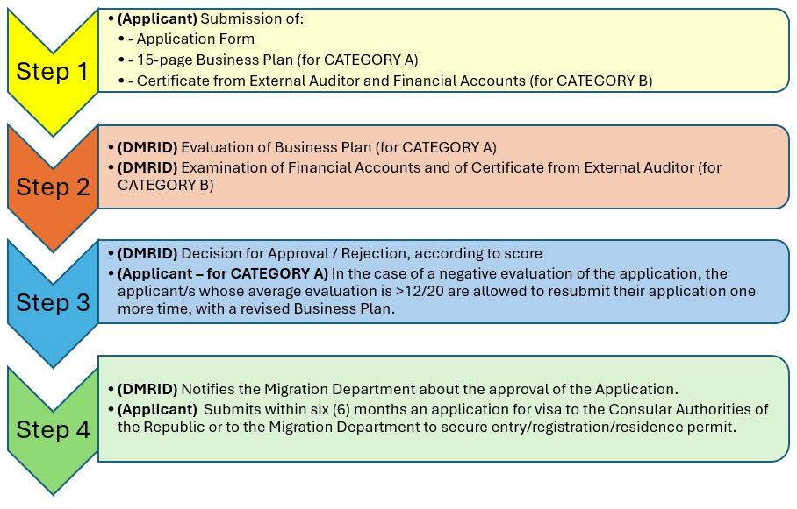

- Objection / resubmission procedure
For CATEGORY A:
In the case of a negative evaluation of the application, the applicant/s will receive a letter containing the overall comments of the evaluators who have evaluated their Business Plan.
Applicant/s who have received a negative evaluation, but whose average evaluation is >12/20, are allowed to resubmit their application one more time, with a revised Business Plan, which takes into account the evaluators’ comments.

- Process for obtaining Approval from the Migration Department

7.a. Submission of an Application of Entry in the Republic of Cyprus
The application’s initial approval does not automatically guarantee a right of entry, residence or employment in the Republic. The Migration Department and the Ministry of Foreign Affairs is notified by the Deputy Ministry about the approval of the Application.
When the applicant/s obtains the Notification of Initial Approval while abroad, they must submit within six (6) months an application for visa to the Consular Authorities of the Republic or to the Migration Department in order to secure entry/registration/residence permit.
The application will be examined and replied within three (3) weeks after complete submission. In case of approval, the applicant should arrange entry into the Republic within the document’s validity period.

7.b. Submission of an Application of Entry and Work / Residence permit in the Republic of Cyprus
If the applicant/s receive the Notification of Initial Approval while legally staying in the Republic, they must submit within one (1) month an application to the Migration Department to ensure registration/residence permit for the establishment/operation/and development of a Startup.
The application is examined and replied within three (3) weeks after its complete submission. In case of approval, a residence permit is issued, valid for one year from the date of the Notification of Initial Approval.
If the applicant is in the Republic with a visitor status, before submitting the application, they should submit a written request to the Migration Department in order to change their residence status. The request will be reviewed within five (5) weeks.

- Transfer between Individual and Team Visa Scheme
If an application was submitted under the Individual Startup Visa Scheme, it is possible to transfer to the Team Scheme, provided that the requirements of that Scheme are met.
If an application was submitted in the Team Startup visa scheme, at any time within the three (3) years of the Notification of Initial Approval, there is a possibility to complete the maximum number of five (5) team members (Founders and Senior Executives), provided that the requirements of the Scheme are met.
All relevant forms can be found at the Department of Labour website: http://www.mlsi.gov.cy/mlsi/dl/dl.nsf/.
- Right to onboard approved team members
For approved applications under the Team Startup visa scheme and subject to all requirement of the Scheme being met, applicants have the right to complete the maximum number of five (5) team members (Founders and Senior Executives), at any time within the three (3) years of the Notification of Initial Approval.
- Possibility for Additional Recruitment of Foreign Personnel under the Startup Visa Scheme
In addition to the Team that consists solely of the founders or at least one founder and other senior executives, the company -in case it wishes- will be able to recruit additional foreign personnel as follows:
- Up to five (5) individuals without prior approval of the Department of Labour, provided that they will receive a gross monthly salary of at least €1.500. Such personnel shall be entitled to reside and be employed in the Republic, in the relevant company, with a potential of a two-year issue / renewal of residence permits and if the provisions of the immigration law are met, be able to exercise the right to family reunification.

- In the case where the company shows investment in Cyprus equal or higher than € 150.000, then the company will be able to recruit up to 10 more foreign personnel in excess of the five (5) individuals of 10(i), without a prior approval from the Department of Labour.
- In both cases, the company will be able to recruit additional foreign personnel in excess of the five (5) of 10(i) above or the total of fifteen (15) individuals of 10(ii) above, by following the established procedures relating to residence and employment of third country nationals, with a prior approval from the Department of Labour. For these personnel the policy governing General Employment will be applied. The Department of Labour approves additional recruitment of foreign personnel in cases where the total number of foreign workers in the company does not exceed 50% of the total staff. It is noted that, the company will be excluded from the labour market test in the cases where the monthly gross salary is at least €1.500. A stamped contract by the Department of Labour is required.
All relevant forms can be found at the Department of Labour website: http://www.mlsi.gov.cy/mlsi/dl/dl.nsf/.
- Expiration of the Residence Permit – Re-evaluation Process
Two (2) months before the expiration date of the residence permit, the applicant/s may submit a new application to the Deputy Ministry to assess whether the Startup has been successful or not.
The criteria for the re-evaluation are:
1. Whether the company has proved to be viable (scaling up) – this shall be proved by a presentation of the company’s N-1 or N-2 year’s audited Financial Statements that demonstrate the company's growth as evidenced by increase of at least 15% in revenue or investments of at least 150k EUR during its period of operation in Cyprus (where N = the current year of re-evaluation).
2. Whether the company has contributed to the Scheme’s goal: At least 3 new jobs were created in the company in Cyprus or the company participates in a local incubator/accelerator program or the launch of at least 1 new product/service by the company with the promotion of innovation and research and the development of the local business ecosystem.
3. Proof that the employee(s) of the company have Basic Digital Skills by submitting internationally recognized certificates held by the person/team in specific areas such as IT, Digital Marketing, Data Analytics/Machine Learning, Design/UX, Project Management, New Product Development.
In the case of an individual Startup Visa: submission of at least 2 Certificates owned in the above 6 areas.
In the case of a group Startup Visa: submission of at least 1 Certificate owned in the above 6 areas, for each member of the team.
The Deputy Ministry evaluates them and, if deemed necessary, indicates a specific certificate that a person or group should obtain within a specific time frame and in any case before the visa is re-issued.
The Deputy Ministry of Research, Innovation and Digital Policy approves or rejects the application within five (5) weeks of receiving a completed application.

12.a. If re-evaluation is positive:

If the evaluation is positive, then the applicant/s will receive a Notification of Final Approval within five (5) weeks of submission.

- In cases where there is a registered company with tax residency in the Republic:
- Personnel already working in the company (initial applicants: Founders and Senior Executives), will be ensured the right of residence and employment in the Republic and in the company. For the paid employees, there will be a potential of a two-year issue / renewal of residence permits and for the self-employed, one year, by paying the corresponding fees. Applicants and employees will be able to directly exercise the right to family reunification, in accordance to immigration laws.
- The company, in case it wishes, will be able to recruit additional foreign personnel according to the terms and conditions of paragraph 10.

- In the cases where there is no registered company with tax residency in the Republic:
- The self-employed in the company at the time of issue of the Notification of Final Approval, will be ensured the right of residence and employment in the Republic, in the specific company, with one-year renewal, and by paying the corresponding fees. He/ they will be able to directly exercise the right to family reunification, in accordance to the immigration laws.
- The company, in case it wishes, will be able to recruit additional foreign personnel according to the terms and conditions of paragraph 10. The self-employed founder with the larger number of shares in the company will be considered as the employer. In the case of a partnership, shareholding is not taken into account. Each partner in a partnership pays social insurance fees as an independent self-employee.

12.b. If re- evaluation is negative:
- If the application’s evaluation is negative, the Migration Department will be informed accordingly.
The Migration Department will inform the interested third-country nationals on the need to settle their stay in the Republic otherwise or depart from the Republic

For more information, please contact:
Ms. Elena Poulli, Scientific Officer A’
Deputy Ministry of Research, Innovation and Digital Policy
Email: epoulli@dmrid.gov.cy
Tel.: 22 691921

http://www.reform.gov.cy/gr/
In accordance with the limitation of Regulation 12 of the 1972 Regulations on Foreigners and Immigration Law as it was amended.
In accordance with the limitation of Regulation 12 of the 1972 Regulations on Foreigners and Immigration Law as it was amended.

